Travis Grimmond

Implementation and Testing Unit

I&T 1

Encapsulation in a program

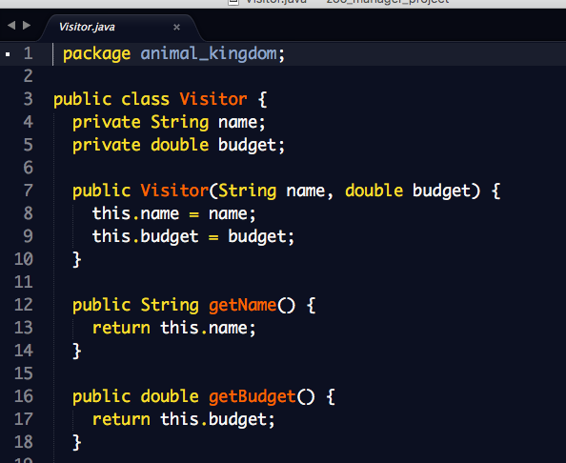

I&T 2

Use of Inheritance in a program

A Super Class

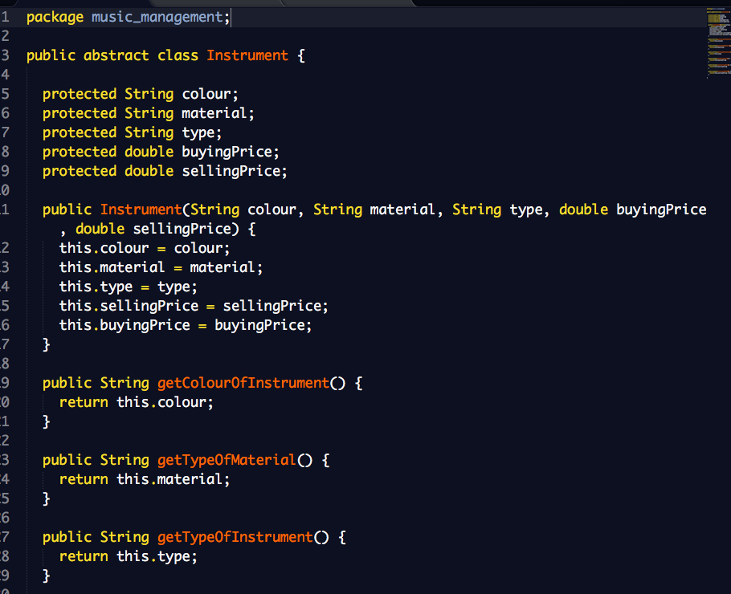

A Class that inherits from a previous class

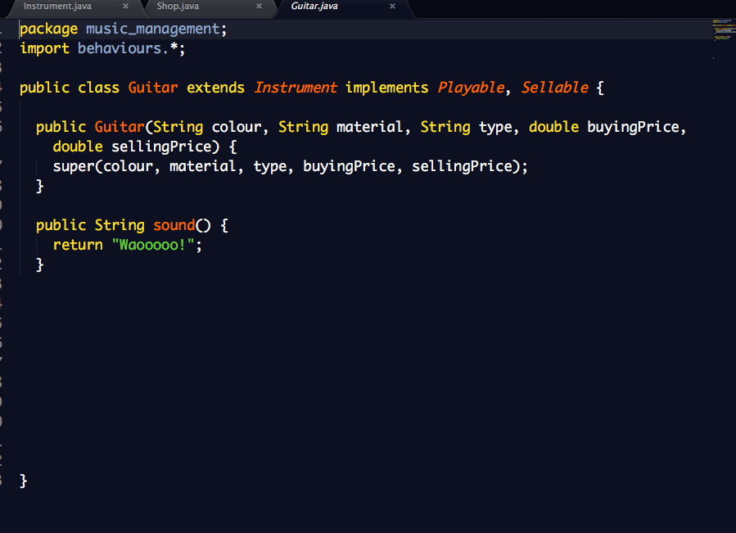

An object in the inherited class

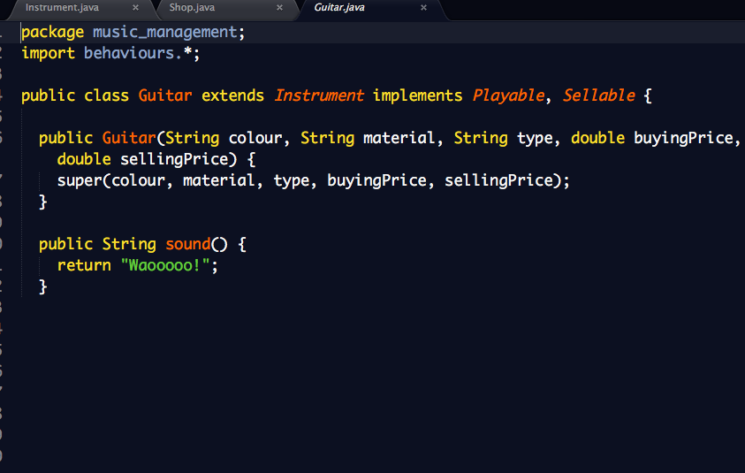

A Method that uses the information inherited from another class

The “ArrayList” contains Instruments of Sellable types

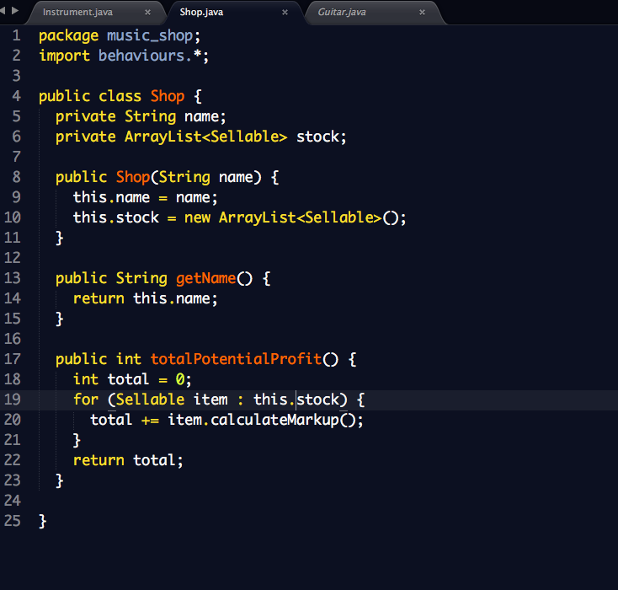

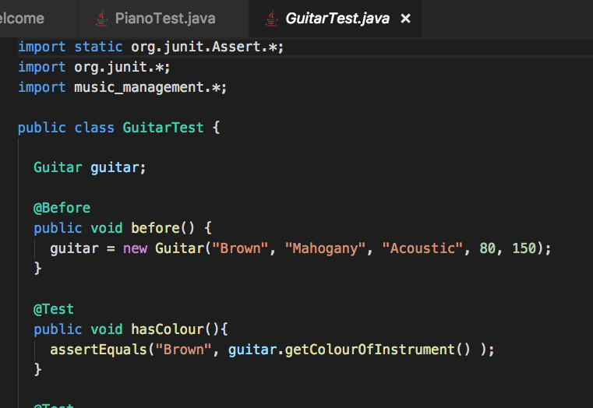

I&T 3

Demonstrate searching data in a program

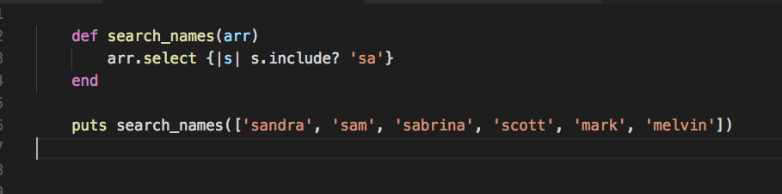

The result from above working

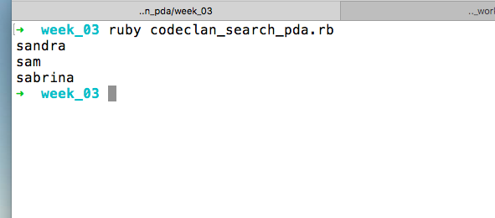

I&T 4

Demonstrate sorting data in a program

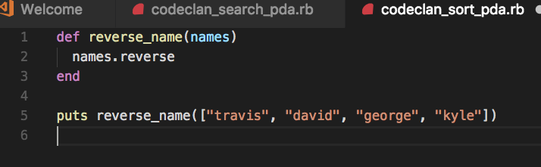

The result from above

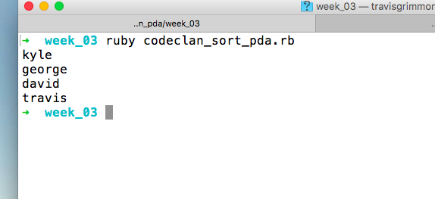

I&T 5

Demonstrate the use of an Array

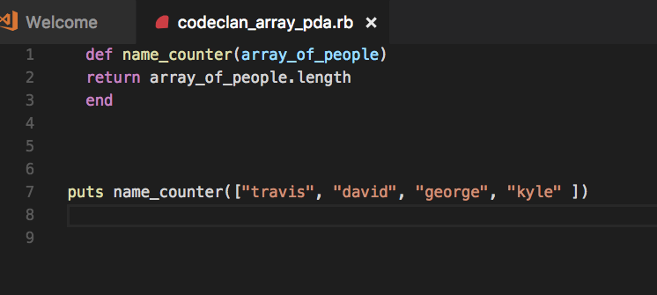

The Result of above

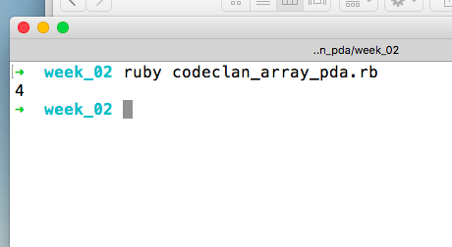

I&T 6

Demonstrate the use of a Hash

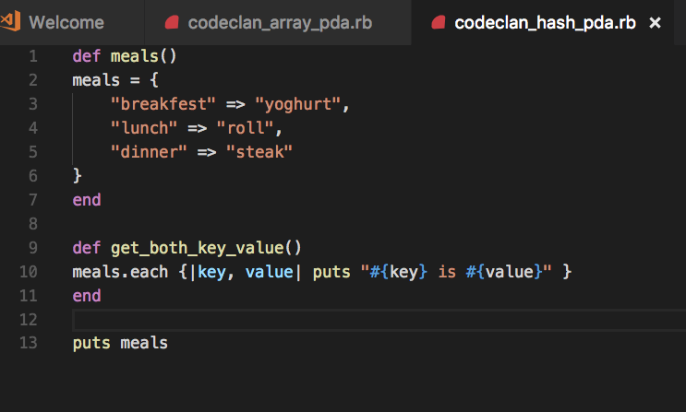

The result of above

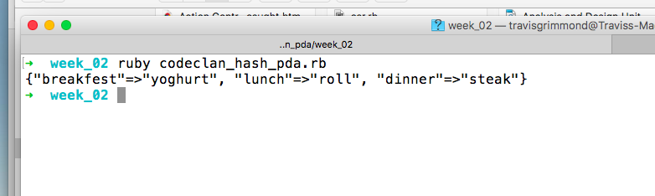

I&T 7

Demonstrate the use of Polymorphism

